Title:
_______________________________________________________________________
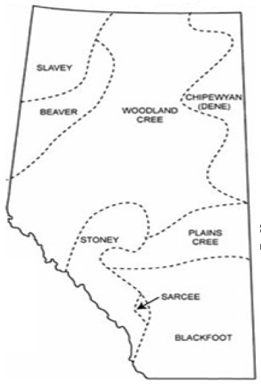

Legend
☐ Canadian Shield
☐ Boreal Forest
☐ Foothills
☐ Rocky Mountails
☐ Parkland
☐ Grassland
Region:
People | Travel | Shelter | Food
___________________  ___________________  ___________________ | ___________________  ___________________  ___________________  ___________________ | ___________________  ___________________  ___________________  ___________________ | ___________________  ___________________  ___________________  ___________________

Picture of the Region:

Region:
People | Travel | Shelter | Food
___________________  ___________________  ___________________ | ___________________  ___________________  ___________________  ___________________ | ___________________  ___________________  ___________________  ___________________ | ___________________  ___________________  ___________________  ___________________

Picture of the Region:

Region:
People | Travel | Shelter | Food
___________________  ___________________  ___________________ | ___________________  ___________________  ___________________  ___________________ | ___________________  ___________________  ___________________  ___________________ | ___________________  ___________________  ___________________  ___________________

Picture of the Region:

Region:
People | Travel | Shelter | Food
___________________  ___________________  ___________________ | ___________________  ___________________  ___________________  ___________________ | ___________________  ___________________  ___________________  ___________________ | ___________________  ___________________  ___________________  ___________________

Picture of the Region:

Region:
People | Travel | Shelter | Food
___________________  ___________________  ___________________ | ___________________  ___________________  ___________________  ___________________ | ___________________  ___________________  ___________________  ___________________ | ___________________  ___________________  ___________________  ___________________

Picture of the Region:

Region:
People | Travel | Shelter | Food
___________________  ___________________  ___________________ | ___________________  ___________________  ___________________  ___________________ | ___________________  ___________________  ___________________  ___________________ | ___________________  ___________________  ___________________  ___________________

Picture of the Region:

